LAB 2 – MANUAL
Objective
In this lab, you will learn how frequency-domain tools are used to analyze and design communication signals and systems. You will explore Fourier series and Fourier transforms, practical FFT-based spectral analysis, sampling theory (aliasing, anti-aliasing, reconstruction), and convolution (time-domain vs frequency-domain implementations).

Lab Outline
- Setup & Helper Utilities
- Fourier Analysis
  - Fourier Series reconstruction (square and triangle waves)
  - Gibbs phenomenon and convergence behavior
  - Parseval’s relation (power/energy equivalence)
- Fourier Transform & Spectral Analysis
  - Windowing and spectral leakage
  - Amplitude/phase estimation from FFT
- FFT Practicalities
  - fft / ifft and fftshift
- Sampling Theory
  - Nyquist condition and aliasing
  - Anti-aliasing filter before downsampling
  - Interpolation / reconstruction intuition (ZOH vs LPF-based)
- Convolution
  - RC-like impulse response smoothing

Procedure
Step 1 – Launch MATLAB
Open MATLAB R2024b on your workstation.
Step 2 – Load the Lab Script
Load the file Lab2.m into MATLAB.
To run a block of code, use Run Section in the Editor panel (or press CTRL + ENTER).

Part 0 – Setup (Run Once)
Pre-Lab Setup
Run the section labeled 0) Setup (Run Once).

Part 1 – Fourier Analysis: Fourier Series & Reconstruction
In communication systems, periodic signals are often modeled as sums of sinusoids. Fourier series reconstruction builds intuition for bandwidth, harmonics, and distortion.

1.1 Square Wave Reconstruction (Gibbs Effect)
Run section 1.1 Square Wave: Synthesis by Odd Harmonics (Gibbs).
You will reconstruct a square wave using a partial sum of odd harmonics.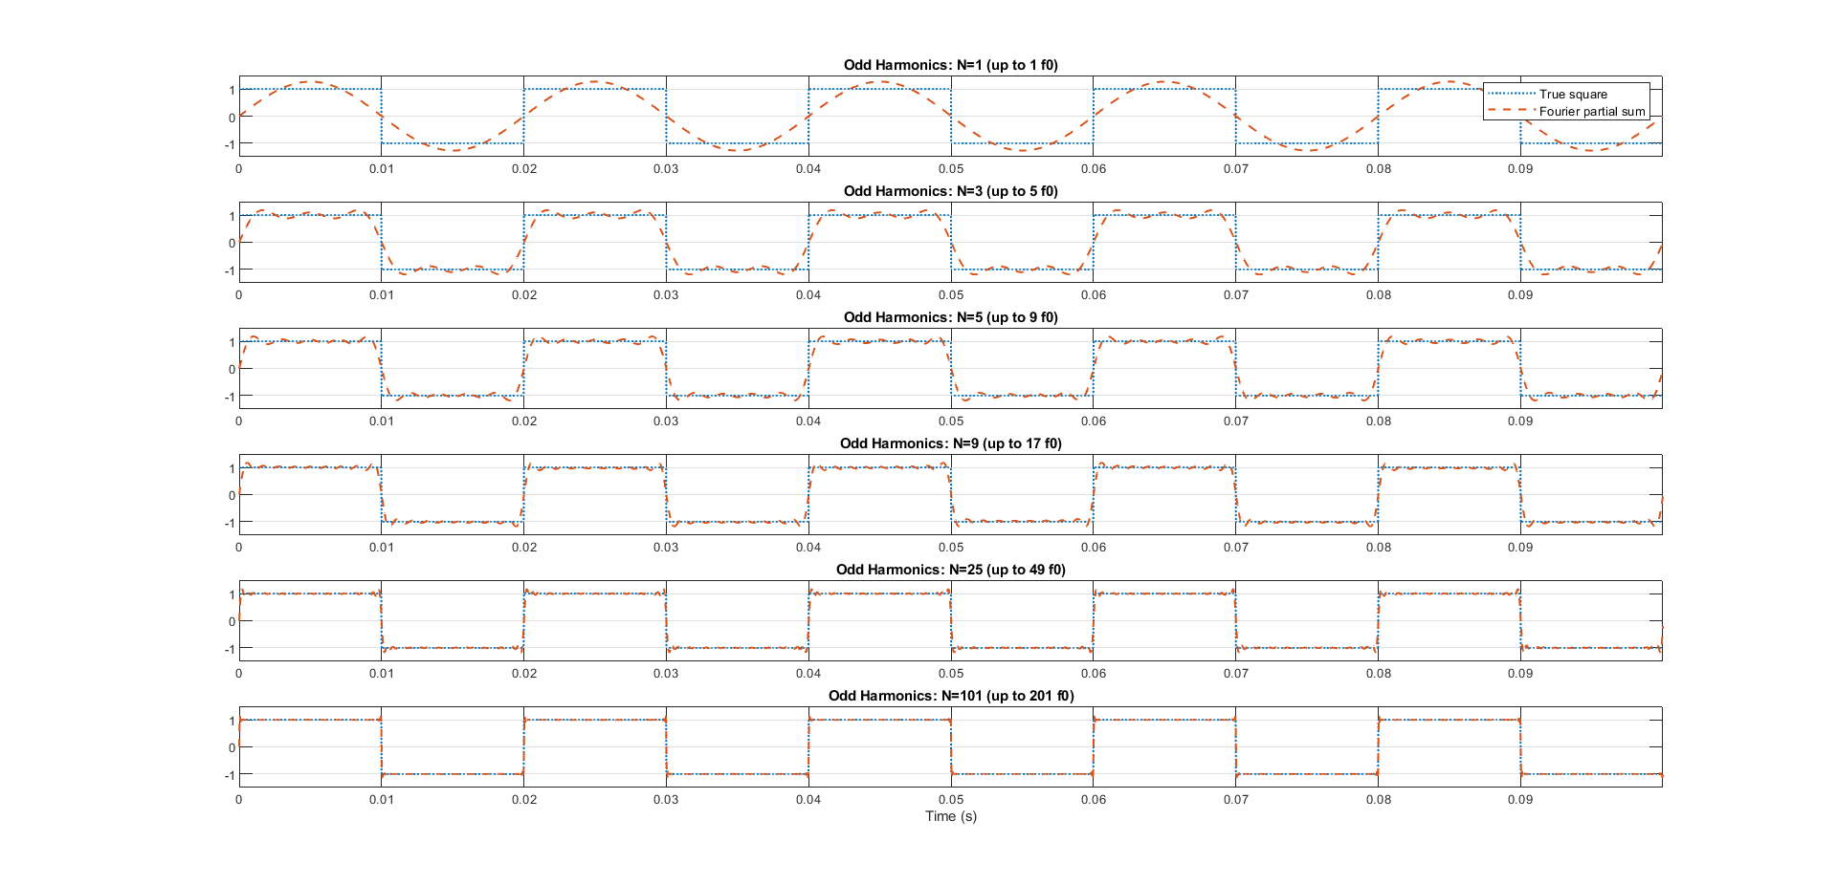
Figure 1. Square Wave Fourier Series (Partial Sums)
Questions
- What changes as the number of harmonics increases?
- Explain the overshoot near discontinuities (Gibbs phenomenon). Does it disappear with more harmonics?
- Why are only odd harmonics used for an ideal square wave?

1.2 Triangle Wave Reconstruction (Faster Convergence)
Run section 1.2 Triangle Wave
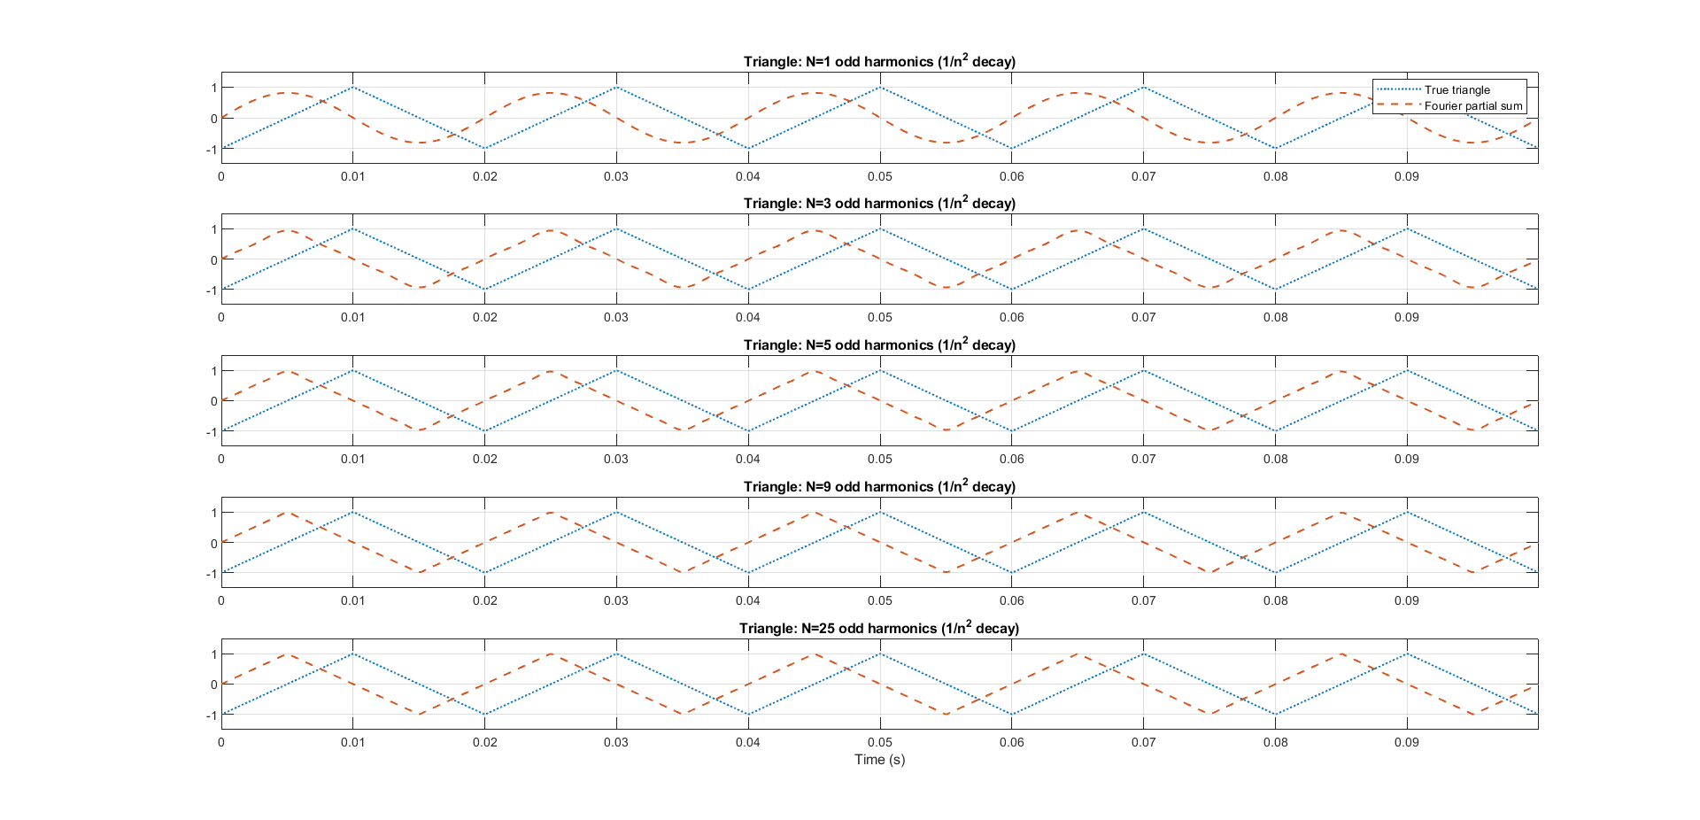
Figure 2. Triangle Wave Fourier Series (Partial Sums)
Questions
- Why does the triangle wave converge “faster” than the square wave?
- Relate smoothness of a waveform to the decay rate of its Fourier coefficients.

1.3 Parseval Check (Time Power vs Coefficient Power)
Run section 1.3 Parseval Check (energy of one period).
The script estimates average power in two ways:
- From the time-domain reconstructed waveform
- From the harmonic coefficient amplitudes
Figure 3. Parseval Consistency Check Output
Questions
- What does Parseval’s relation mean physically?
- Why might the two results not match perfectly (numerical approximation, finite harmonics, finite sampling)?

Part 2 – Fourier Transform & Spectral Analysis
In communications, we often use FFT-based spectra to identify tones, bandwidth, leakage, and noise floors.

2.1 Two-Tone Test & Window Effects (Leakage)
Run section 2.1 (a & b) Two-Tone Test & Window Effects.
Two tones are generated and analyzed using:
- Rectangular window (no window)
- Hann window
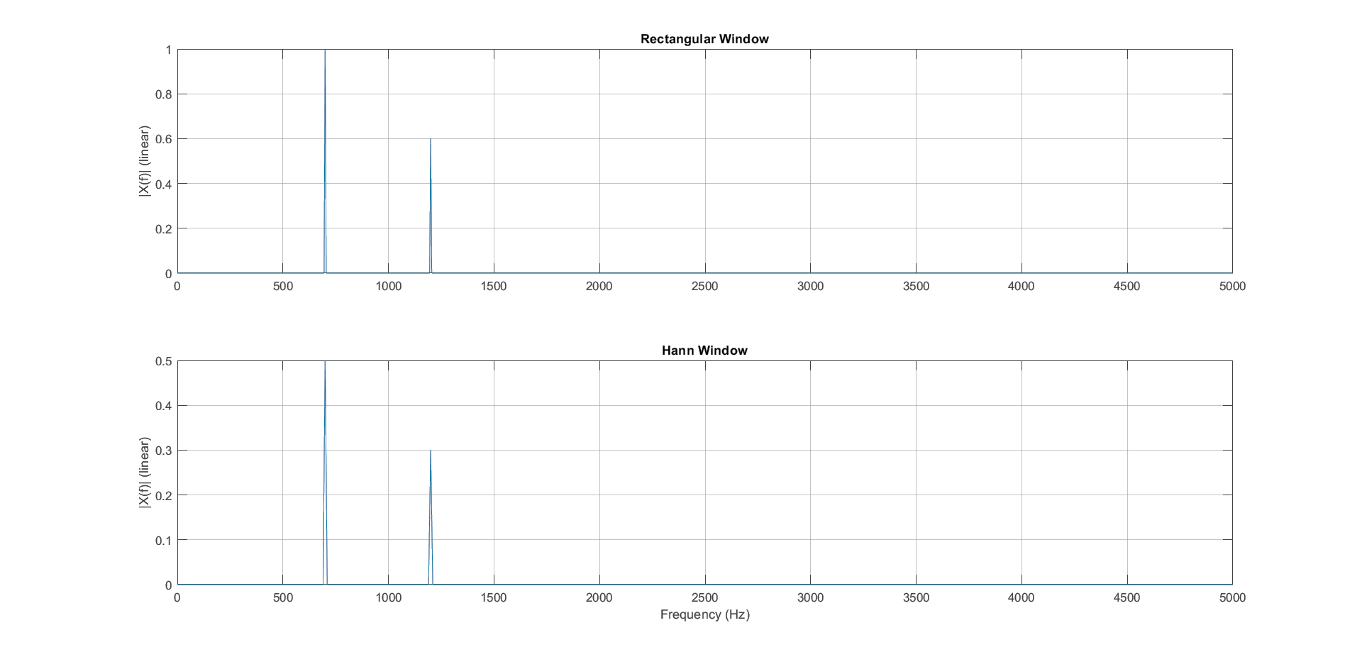
Figure 4. Windowing & Leakage - Linear scale
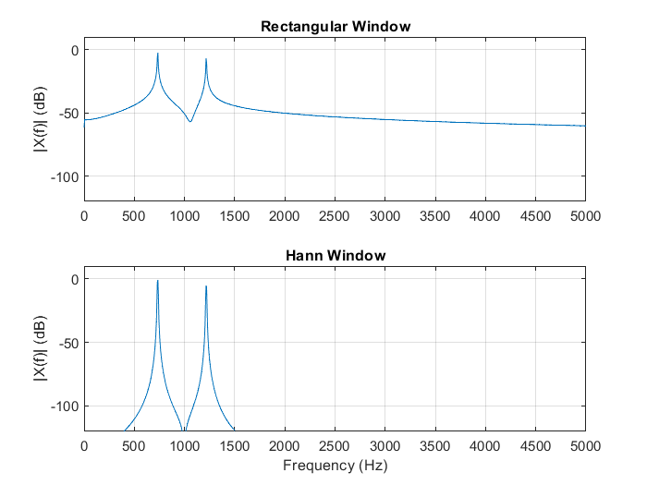
Figure 5. Windowing & Leakage - dB scale
Questions
- Which case shows more leakage? Why?
- What tradeoff does the Hann window introduce (mainlobe width vs sidelobe reduction)?
- If two tones are close in frequency, which window choice makes them easier/harder to separate?

2.2 Phase Retrieval & Amplitude Calibration
Run section 2.3 Phase Retrieval & Amplitude Calibration.
You will estimate amplitude and phase of a single tone using FFT bin alignment.
Figure 6. Tone Amplitude/Phase Estimation
Questions
- Why must the tone be aligned to an FFT bin to get an accurate amplitude/phase estimate?
- What does “integer number of periods in the record” mean and why does it matter?
- Compare estimated vs true amplitude and phase. What causes small mismatch?

Part 3 – FFT Practicalities

3.1 fft / ifft and fftshift Basics
Run section 3.1 fft, ifft, and fftshift Basics.
You will view a two-sided spectrum centered around DC using fftshift.
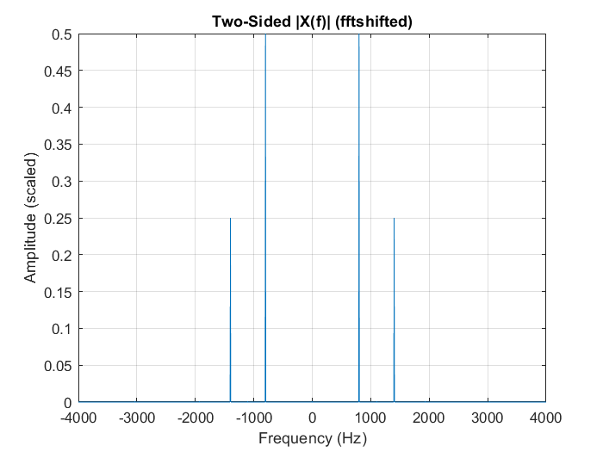
Figure 7. Two-Sided Spectrum with fftshift
Questions
- What does fftshift change in the plot (interpretation of frequency axis)?
- Why do we often prefer centered spectra in communications and baseband analysis?
- What does it mean when a spectrum is symmetric?

Part 4 – Sampling Theory
This part builds intuition for Nyquist, aliasing, and the need for anti-aliasing filters.

4.1 Aliasing Demonstration
Run section 4.1 Aliasing Demonstration.
A 9 kHz tone is sampled at:
- fs = 50 kHz (safe)
- fs = 18 kHz (near Nyquist)
- fs = 12 kHz (below Nyquist → alias)
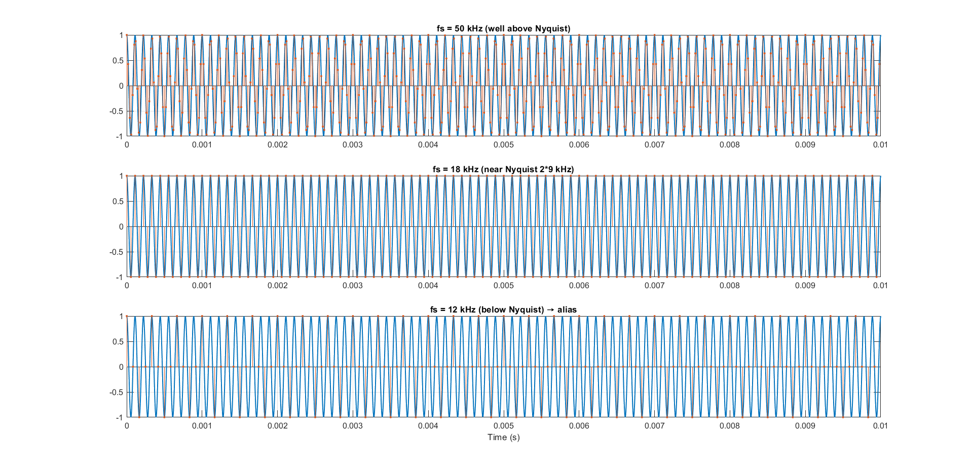
Figure 8. Aliasing Demo (Three Sampling Rates)
Questions
- Which subplot shows aliasing? How can you tell visually?
- Compute the Nyquist rate for the 9 kHz tone.
- Estimate the aliased frequency when fs = 12 kHz (explain using the folding idea).

4.2 Anti-Aliasing Filter before Downsampling
Run section 4.2 Anti-Aliasing Filter before Downsampling.
A signal contains:
- An in-band tone (9 kHz)
- An out-of-band tone (22 kHz)
You apply an anti-aliasing LPF before decimation.
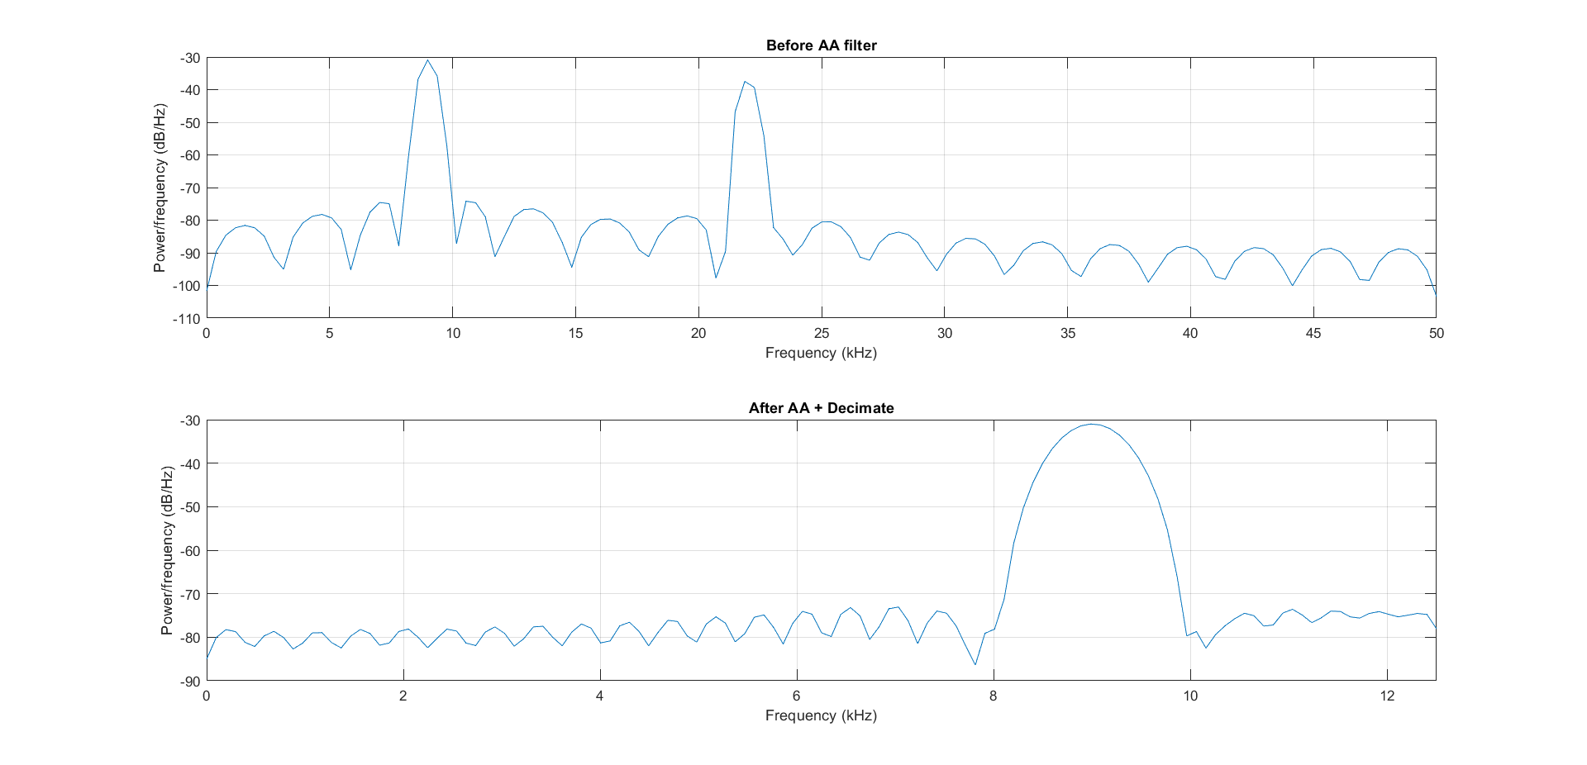
Figure 9. PSD Before vs After Anti-Aliasing + Decimation
Questions
- What would happen if you downsampled without the anti-aliasing filter?
- In a real receiver, what physical blocks act like anti-aliasing filters?

4.3 Interpolation / Reconstruction Intuition
Run section 4.3 Interpolation / Reconstruction (sinc intuition).
You compare:
- Zero-order hold (staircase)
- Upsample + LPF reconstruction
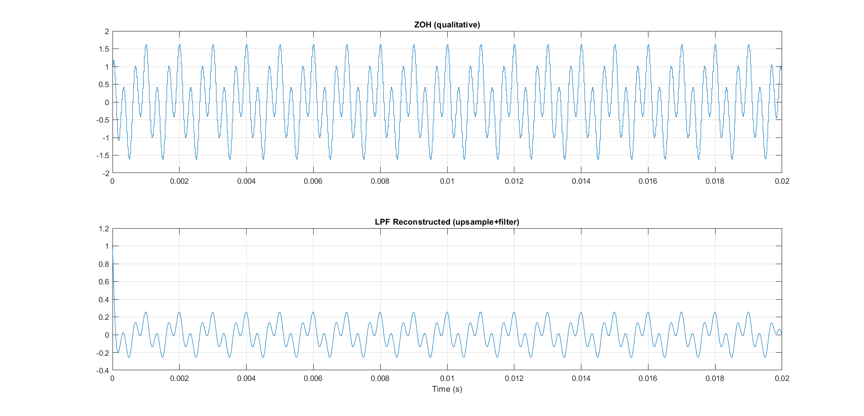
Figure 10. Reconstruction: ZOH vs LPF-Based
Questions
- Why does ZOH look “blocky”?
- What does the LPF do after upsampling?
- What is the ideal reconstruction filter for bandlimited signals (conceptually)?

Part 5 – Convolution

5.1 RC-like Impulse Response and Convolution
Run section 5.1 RC-like Impulse Response and Convolution.
A square wave is passed through an RC-like impulse response (smoothing effect).
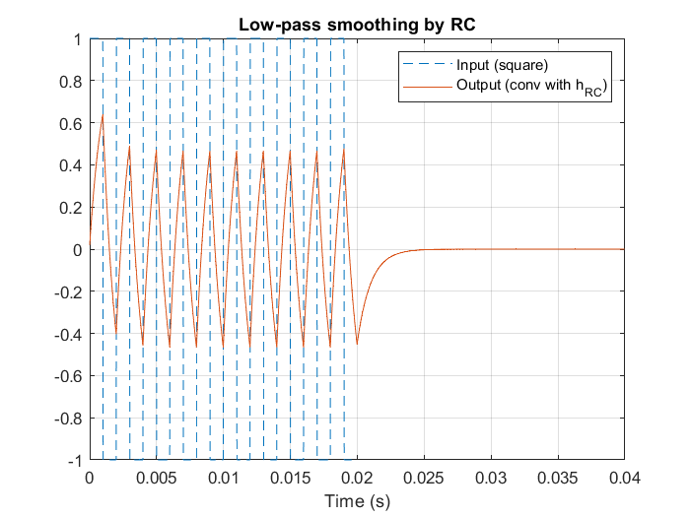
Figure 11. RC Response to Square Wave (Smoothing by LPF)
Questions
- Why does convolution with an RC impulse response smooth sharp edge?
- Relate this behavior to lowpass filtering and bandwidth limitation.
- What does the parameter RC control (time constant / “speed” of response)?

